**File Operations**

**1.Create a new Excel workbook.**

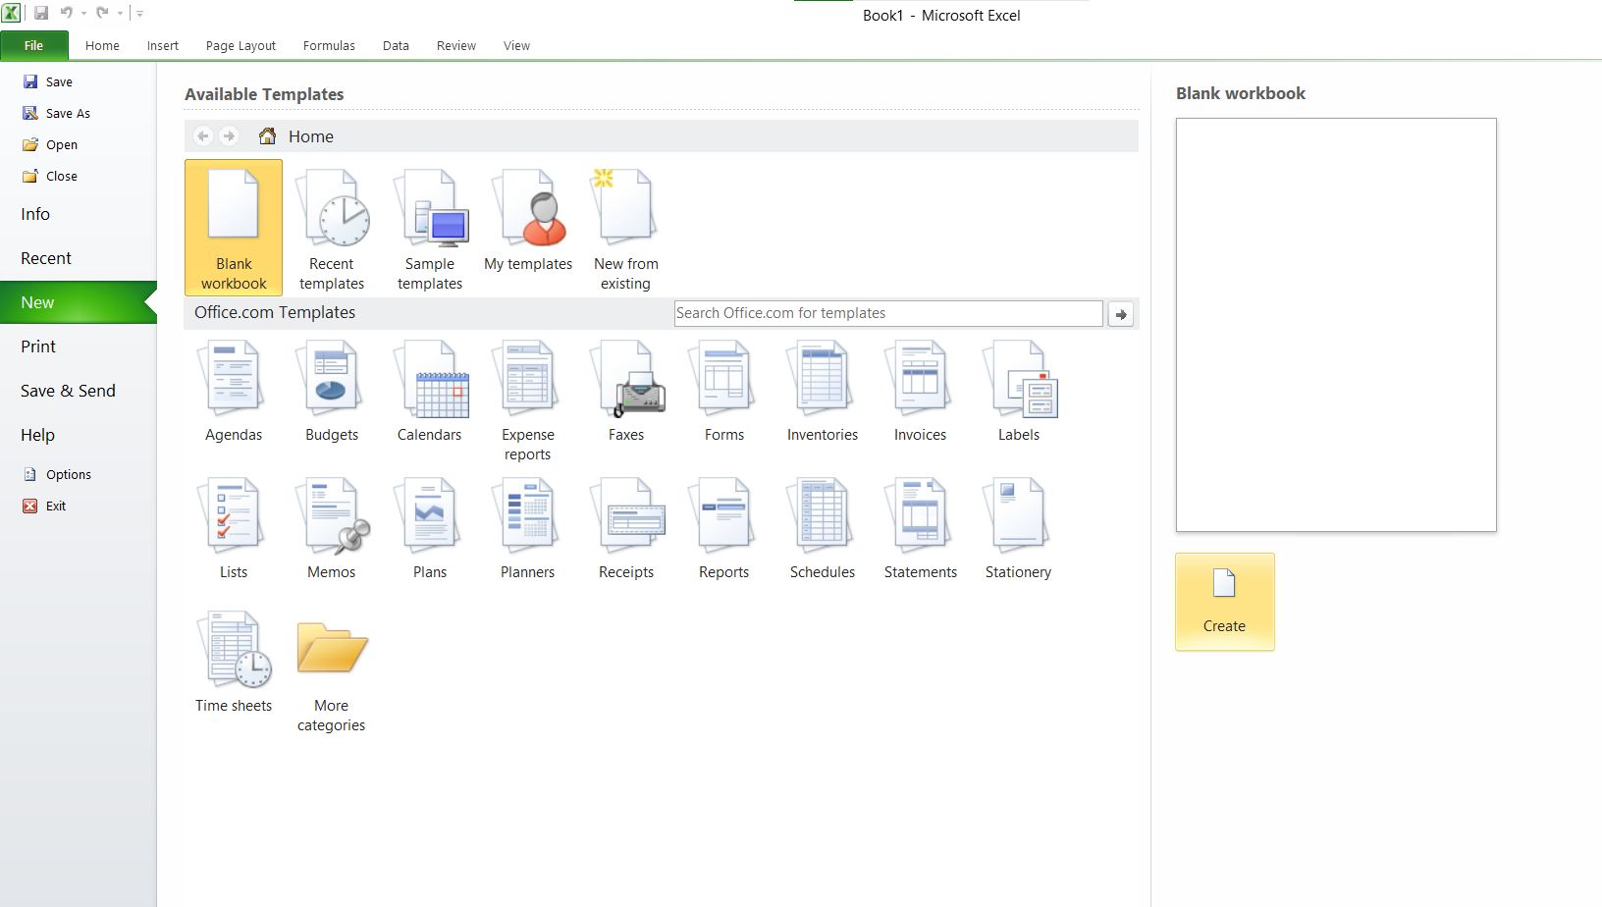

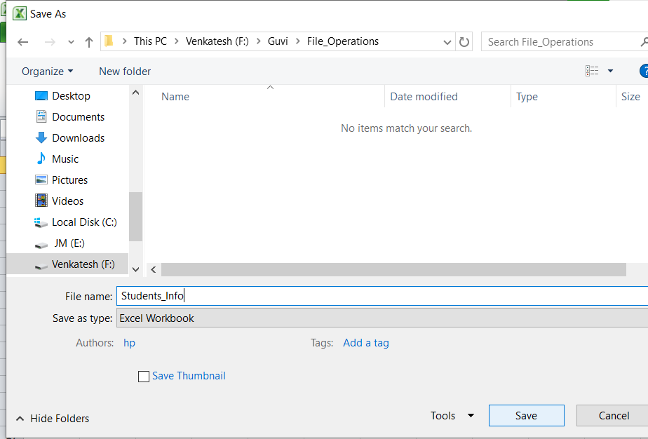

**2.Create a new sheet with the name "Sheet1".**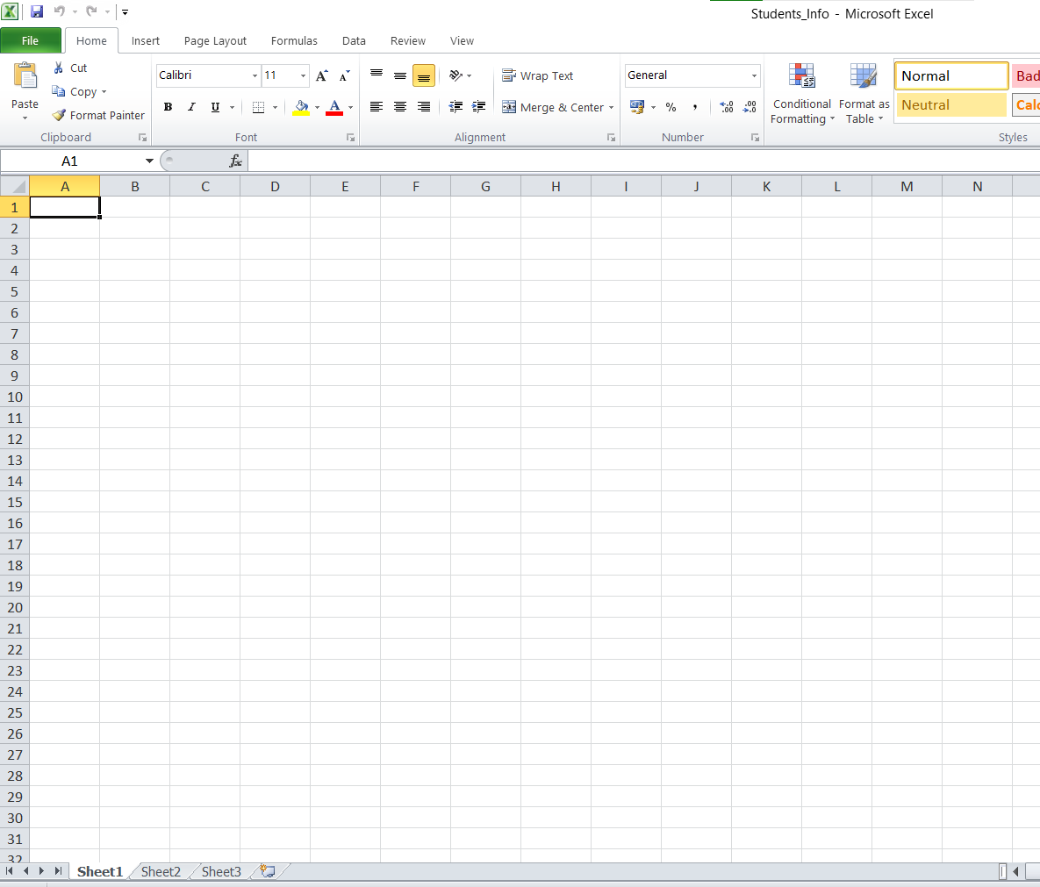

**3. Write the following data to the sheet:**

Column headers: Name, Age, Email

Row 1: John Doe, 30, john@test.com.

Row 2: Jane Doe, 28, john@test.com.

Row 3: Bob Smith, 35, jacky@example.com.

Row 4: Swapnil, 37, swapnil@example.com.

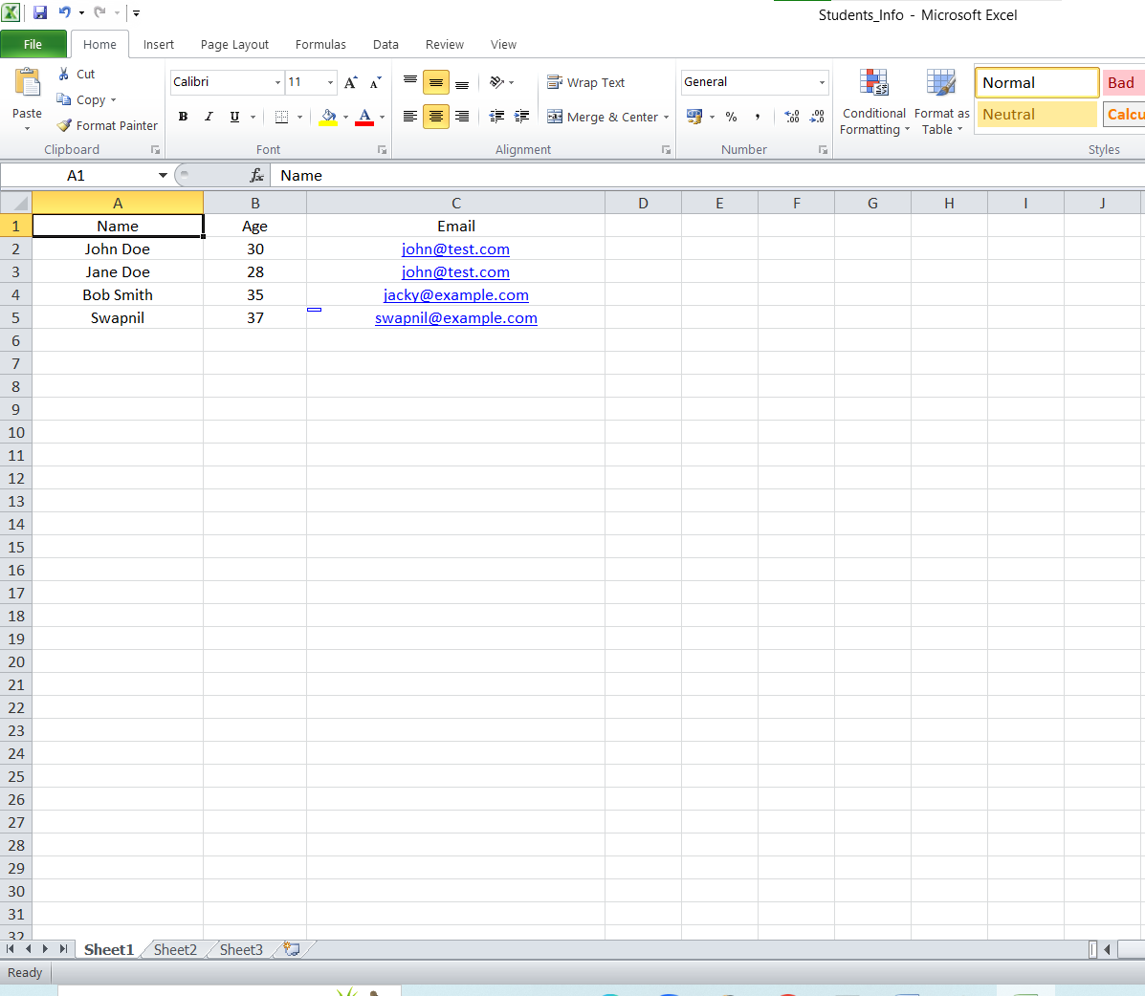

**Convert the project into Maven project**

**Add the below mentioned dependencies to pom.xml**

